2.66: a) The simplest way to do this is to go to a frame in which the freight train (which moves with constant velocity) is stationary. Then, the passenger train has
an initial relative velocity of v_{rel,0} = 10 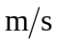. This relative speed would be decreased to zero after the relative separation had decreased to 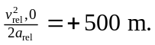 Since this is larger in magnitude than the original relative separation of 200 m, there will be a collision. b) The time at which the relative separation goes to zero (i.e., the collision time) is found by solving a quadratic (see Problems 2.35 & 2.36 or Example 2.8). The time is given by
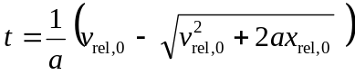
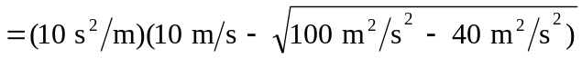
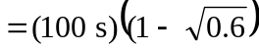.

Substitution of this time into Eq. (2.12), with x₀ = 0, yields 538 m as the distance the passenger train moves before the collision.

